(14P) S6. Perform an application using an LCD for your Rpi or STM32 board:
Purpose of Application: Write your names and surnames on the first and second line of the screen (e.g., first line: Kemal Avci; second line: Selami Beyhan). Note: If you are the single in the group, write your name and surname in the first line and your birth date in the second line.
Circuit Diagram: You are free to build your circuit for application. Draw your circuit in Fritzing.
Restriction: Neither the Arduino IDE nor the Arduino programming language will be used when performing this application. Use only Thonny IDE with MicroPhython or STM32CubeIDE with C/C++.
Homework Submission: Record a video with all the team members for your application. In your video content; explain your program codes, show your program to be compiled successfully, show your program to be loaded to your board, show your circuit to be run successfully.
The following files need to be uploaded to Teams.
- This word document by completing the ANSWERS section (do not upload as pdf)
- Your video file
- Fritzing circuit file
- Application project folder created by IDE software
------------------------------------------------ANSWERS-----------------------------------------------
Project Team: Onur Ümit Şener

Fritzing Circuit Diagram:
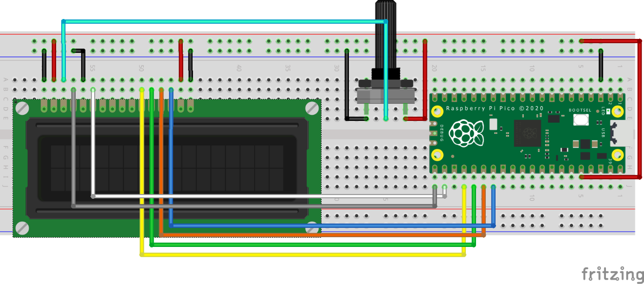
Program codes:
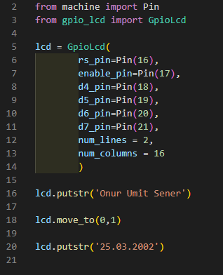

Photo for your circuit (only 1 photo):
